

# Heading

Text

# Heading

Text

# Heading

Text

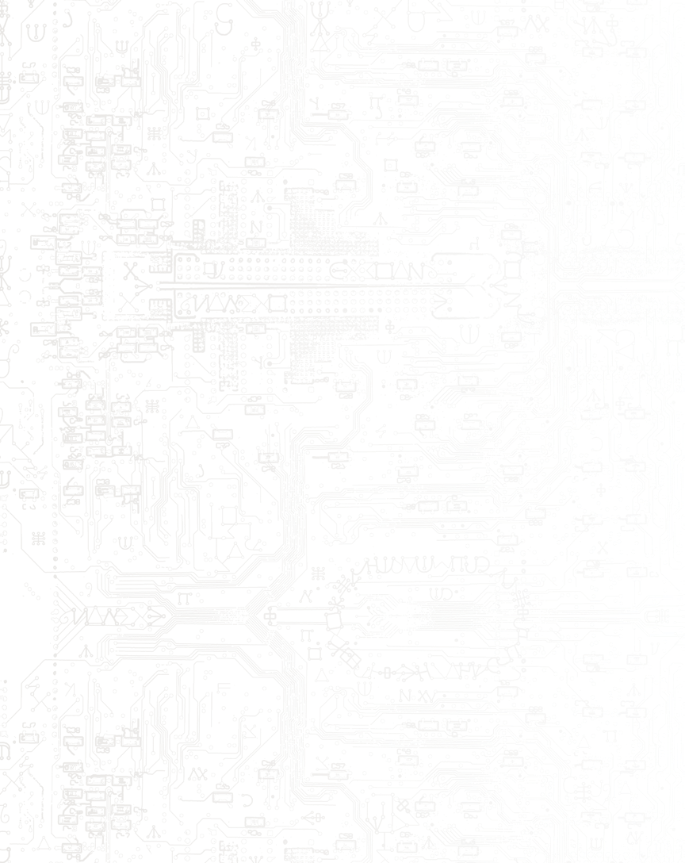

# Type to enter text

# Type to enter text

# Type to enter text